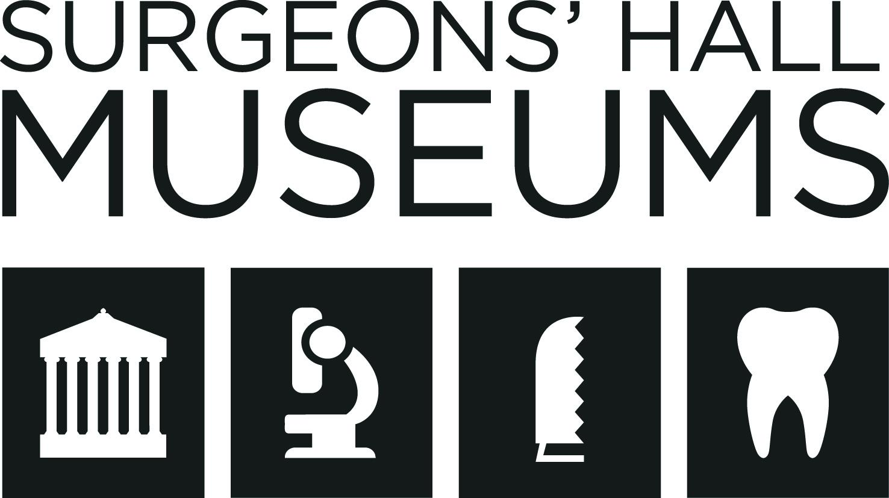

Accessibility Guide for Surgeons' Hall Museum
museum@rcsed.ac.uk, 01315271711, https://museum.rcsed.ac.uk/
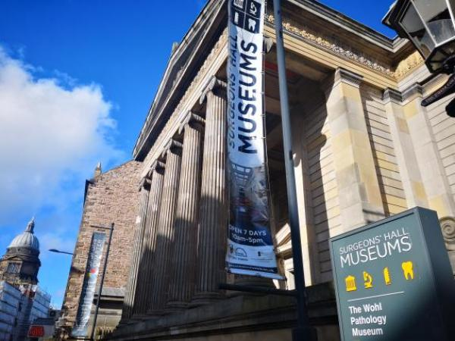

Welcome
Surgeons' Hall Museums are part of the Royal College of Surgeons of Edinburgh which was founded in 1505 and is one of the oldest medical institutions in the world. The museum expanded hugely in the 1800's to include the remarkable collections of Sir Charles Bell and John Barclay.
Our fascintating collections of bone and tissue specimens, surgical instruments and artworks are spread over two buildings connected by a central stairway.

At a Glance

Level Access
- There is level access from the main entrance to:
  - History of Surgery Museum
  - Lower Level of Pathology Museum
  - Upper Level of the Wohl Pathology Museum
  - Dental Collection
  - Body Voyager Galleries
  - Museum Ticket Desk
  - Basement toilets
  - Body Voyager Toilet

Hearing
- We have a hearing loop in History of Surgery Museum.

General
- We have a concessionary rate for disabled visitors.
- We have a complimentary ticket policy for personal assistants.
- There is at least 1 public toilet for disabled visitors.

Getting here
Surgeons' Hall Museum
Nicolson Street
Edinburgh
EH8 9DW

Travel by public transport
- You can get to Surgeons' Hall Museum by bus.
- The nearest bus stop outside Sainsbury's Local on Nicolson Street. It is an approximately 2 minute walk from the entrance to the courtyard leading to the museum. The bus stop name is "Surgeons' Hall" The bus stop is 0.06 miles / 3.2 km from Surgeons' Hall Museum.
- The nearest bus stop on the same side of the road of the museum is about 0.1 miles / 0.2 km from the museum gates and then there is a short walk (less than 1 minute) from the gates to the entrance of the building. There are benches in the museum gardens if you require a seat.
On the opposite side of the road (as if you were heading towards Princes Street) the nearets bus stop is directly opposite the Sainsbury's local. The bus stop is 0.04 to the nearest pedestian crossing which is directly opposite the museum. It is 0.2 miles / 0.2 km from the crossing to the gates of the museum

Travel by taxi
- You can get a taxi with City Cabs by calling 0131 228 5319 . The taxi company has a wheelchair accessible vehicle.

Parking
- The museum is located on the busy Nicolson Street and therefore it may not always be possible to drop off outside the main museum entrance. If drop off is not possible outside the main museum entrance then it is possible to drop off on Hill Place (a quieter side street) which is 0.06 miles from the entrance gates of the museum. Due to our city center location we do not have parking available for visitors. However there is on street parking on Richmond Place whihc is a 0.1 mile walk (approximately 3 minutes) from the entrance of the museum.

Arrival

Path to main entrance
- From the street to the main entrance, there is level access.
- The path is 1295mm wide, or more.

Main entrance
- The main entrance has level access.
- The door is 1397mm wide.
- The main door is side hung and automatic.
- The ticket desk to the museum is located on level 3 of the building. There are automatic glass doors into the atrium and there is lift access to level 3 at the back of the atrium.
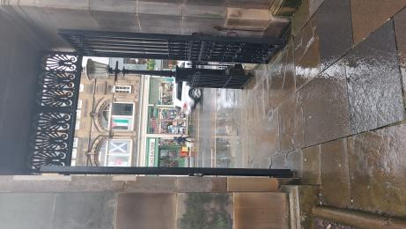
The gate to the main entrance
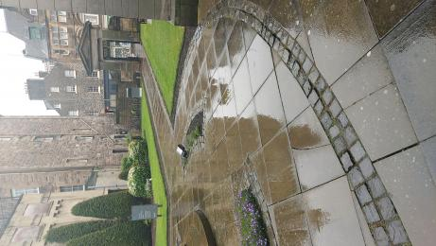
Photo of the garden, showing the narrowest part of the path
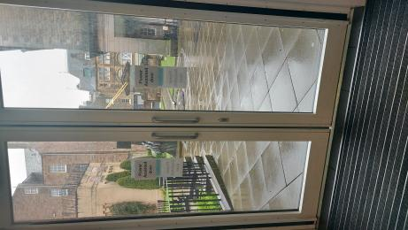
Automatic glass doors at the main entrance

Getting around inside

Lift
- We have 1 lift.
- You can get a lift to all floors.

Lift to all floors
- The lift door is 901mm wide.
- The lift is 1117mm wide. The lift is 2336mm deep.
- The lift says the floor number at each floor.
- The lift buttons have raised numbers or letters.
- The lift shows the floor number, at each floor.
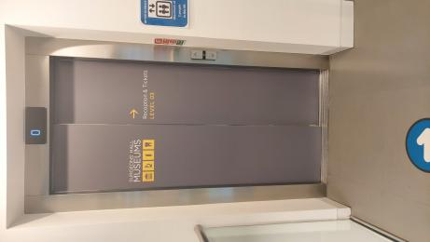
Photo showing the lift door
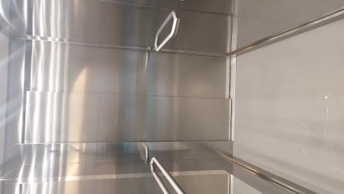
Inside the lift. There are doors on either side
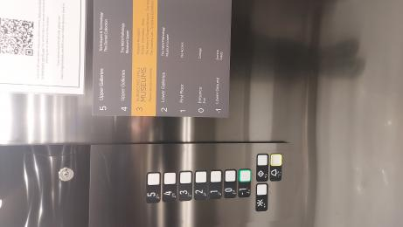
The lift buttons showing the raised areas near the buttons

Ticket/ information desk

Museum Ticket Desk
- From the main entrance to the desk, there is level access. There is a lift.
- From the lift to the ticket desk, the route is 1346mm mm wide, or more.
- The door is 1168mm wide, or more.

Things to See and Do
- We have a concessionary rate for disabled visitors.
- We have a complimentary ticket policy for personal assistants.

History of Surgery Museum
- From the main entrance to this area, there is level access. There is a lift.
- From the lift to this area, the route is 1295mm wide, or more. The door is 1295mm wide.
- Some display information is low, for wheelchair users. Videos have subtitles.
- The History of Surgery Museum is located on the same level as our ticket desk and gift shop. There are several different types of interpretation in this area: standard museum labels; touch screens with additional information; videos and a recreation of an anatomy theatre. The anatomy theatre is a show which recreates the first legal dissection in Scotland. It has 3 levels of raked seating around a dissection table. The body on the table has anatomical drawings projected on it and a video explaining the dissection plays opposite the theatre. While the seating is tiered there is space (533mm) between the table and the first row of seats. The show lasts for 10 minutes.
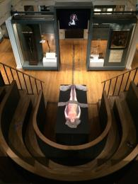
Image showing the layout of the anatomy theatre including the placement of the video screen

Lower Level of Pathology Museum
- From the main entrance to this area, there is level access. There is a lift.
- From the lift to this area, the route is 927mm wide, or more. The door is 1168mm wide.
- Some display information is low, for wheelchair users. There are seats.
- Videos have subtitles.
- The lower level of our Wohl Patholgy Museum is fully accessible by lift. It is a wide and bright area. There are some videos throughout the gallery as well as several benches.

Upper Level of the Wohl Pathology Museum
- From the main entrance to this area, there is level access. There is a lift.
- From the lift to this area, the route is 927mm wide, or more. The door is 1117mm wide.
- Some display information is low, for wheelchair users.
- There is a portion of the upper gallery in the Wohl Pathology Museum that may not be accessible to wheelchairs wider than 66cm. However there are accessible interactive touch screens which display the items in these restricted sections.We can provide smaller wheelchairs for those able to transfer.

Dental Collection
- From the main entrance to this area, there is level access. There is a lift.
- From the lift to this area, the route is 736mm wide, or more. The door is 736mm wide.
- Some display information is low, for wheelchair users. There is a hearing loop.
- Videos have subtitles.
- The dentistry collection is located on level 5 and is fully accessible by lift.
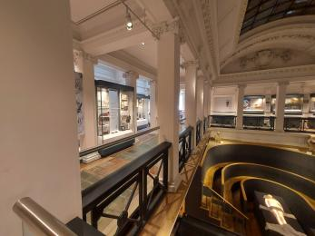
Image showing the layout of the dentistry collection
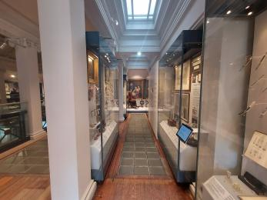
Image showing some cases in the dentistry collection

Body Voyager Galleries
- From the main entrance to this area, there is level access. There is a lift.
- From the lift to this area, the route is 736mm wide, or more. The door is 736mm wide.
- Some display information is low, for wheelchair users. There are seats.
- Videos have subtitles.
- Body Voyager is located on level 5. Visitors have to go through the dentistry area to access Body Voyager. The narrowest part of this galleries are the doors at 863.6mm, the rest of the space is wide and unobstructed. There are many interactive elements in this area. All areas are com
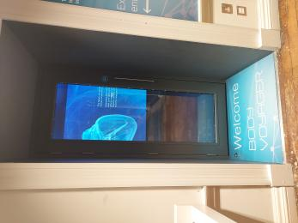
The entrance to Body Voyager from the dental collection on level 5. The door is 863mm wide
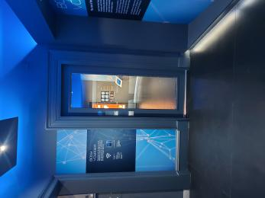
The second door to access the Body Voyager galleries. The door is 787.4mm wide
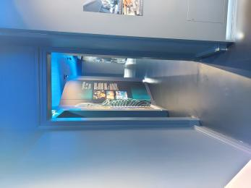
Doorway from section one of Body Voyager gallery to section 2.
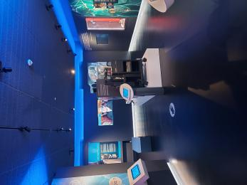
Layout of Body Voyager

Public toilet

Basement toilets
- From the main entrance to the public toilet, there is level access. There is a lift.
- From the lift to the public toilet, the route is 1231mm wide, or more.
- The toilet door is 876mm wide.
- The direction of transfer onto the toilet is to the right.
- There is 939mm at the side of the toilet. There is 1219mm in front of the toilet. The toilet seat is 482mm high. The toilets have handrails.
- The toilets are fully accessible by lift and can be found on level -1. The door leading into to the toilet corridor is 354 mm. There is one accessible toilet. The sink is 736.6 mm from the floor and the hand dryer is also 736.6 mm from the floor.
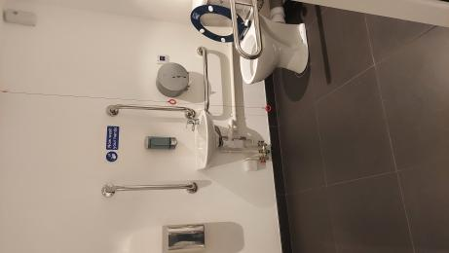
The accessible toilet. Showing the handrails, lowered sink and hand dryer and pull cord.
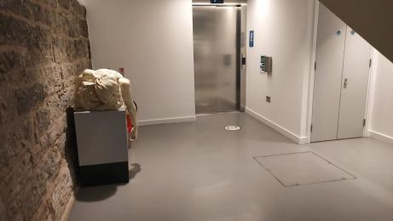
The space between the lift and the corridor with the toilets.
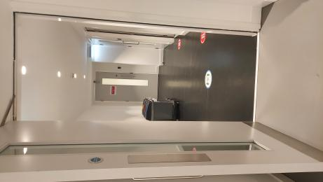
The corridor where the toilets are located. The doorway is 889 mm

Public toilet

Body Voyager Toilet
- There is a public toilet for disabled visitors.
- From the main entrance to the public toilet, there is level access. There is a lift.
- From the lift to the public toilet, the route is 736mm wide, or more.
- The toilet door is 863mm wide.
- The direction of transfer onto the toilet is to the right.
- There is 1320mm at the side of the toilet. There is 2108mm in front of the toilet. The toilet seat is 482mm high. The toilets have handrails.
- The toilets are located in the Body Voyager galleries on level 5. They are at the end of a corridor marked toilets. The sink is 685.8mm from the floor and the hand dryer is 711.2mm from the floor.
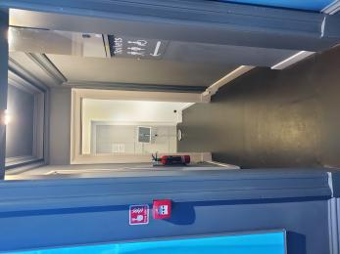
Corridor leading to toilets on level 5
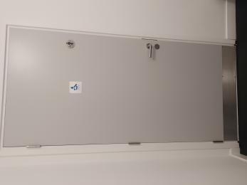
Door to toilet
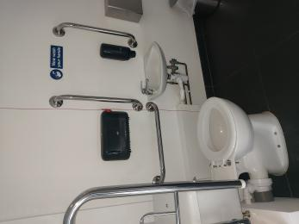
Toilet, handrails, sink and dryer.

Customer care support

Accessibility equipment
- We provide wheelchairs. Wheelchairs are free.
- We have a hearing loop in History of Surgery Museum.
- We have small folding walking stick chairs avaialble to use free of charge. Please let a member of our team know if you would like to use one.
- Nicolson Square Gardens across the road from the museum is a public park. It is a 0.08 miles from the museum gate.

Emergency evacuation procedures
- We have emergency evacuation procedures for disabled visitors.

Guide last updated: 29 April 2022

