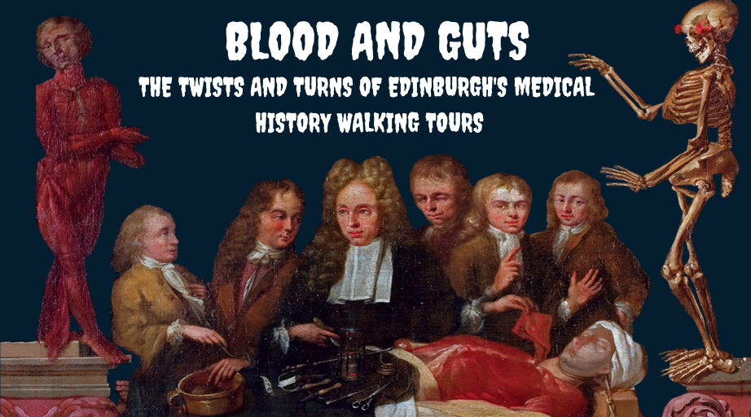Access Statement
Surgeons’ Hall Museums is part of the Royal College of Surgeons of Edinburgh. The Museums are located on Nicolson Street in the Old Town of Edinburgh. We offer our public ‘Blood and Guts: The Twists and Turns of Edinburgh’s Medical History’ seasonally. Tours will run on Saturdays and Sundays at 2pm throughout the year.
Our walking tours start outside Surgeon’s Hall Museums. Tours last approximately 70 minutes and cover 1.2 miles. The longest distance between stops is from Grayfriars Kirkyard to Old Surgeons’ Hall on Infirmary Street. This is a 0.3 mile walk which takes roughly between 8 and 10 minutes.
Tours will start and end at Surgeons’ Hall Museums. Groups will meet their guide outside the Museum at the hand statue in the College courtyard. The courtyard outside the museum is paved and flat.
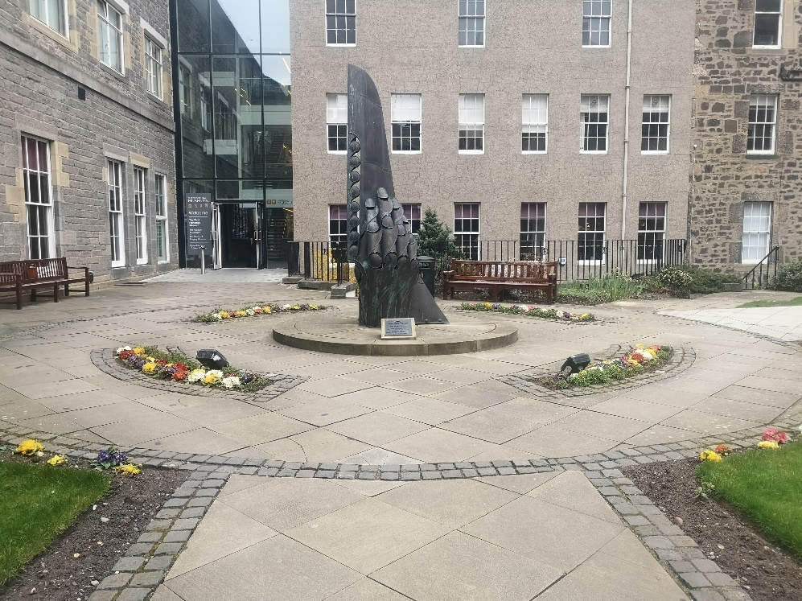
The entrance to Surgeons' Hall Museums
The tour will visit the following places:
- The University of Edinburgh
- Grayfriars Kirkyard (https://www.euansguide.com/venues/greyfriars-kirk-edinburgh-4771)
- Old Surgeons’ Hall, Infirmary Street.
If you would like further information about the route, please get in touch.
Guides are able to adapt the tour route to accommodate accessibility needs. In order to have the best route planned guests should make the guide aware at the start of the tour or contact us via email (museum@rcsed.ac.uk) and we will make the guide aware of your requirements. Please note that due to the historic nature of some of the sites visited on the tour, pets are not allowed. However, assistance dogs are welcome.

Museum Access
Ticket prices also include admission to the museum on the day of your tour. All levels of the Museums are accessible by lift and there are accessible toilets in the basement. The Museums are split into 3: The History of Surgery Museum, The Wohl Pathology Museum and the Dental Collection. Some parts of upper gallery in the Wohl Pathology Museum may not be accessible to wheelchairs wider than 66cm. However, there are interactive touch screens to display the items in these restricted areas. The Museum has its own wheelchairs that are available to help those who can transfer see these restricted areas.

Getting Here
On Foot
Surgeons' Hall Museums is located on Nicolson Street which is approximately a 10 minute walk from Waverley train station.
By BusThere are several buses that pass Surgeons' Hall Museums. Buses 3, 5, 7, 8, 14, 29, 30, 31, 37 and 49 all pass through the city centre and stop near the museum. For information on ticket options and timetables and further journey planning visit the Lothian website.
By Train
The nearest station is Waverley which is just a short walk from the museum. For help with journey planning visit the Trainline's website.
By Car
Due to its city centre location, the museum does not have its own car park. There are however 2 NCP car parks in Edinburgh. The closest is the one located at Holyrood as this is about a 10 minute walk from the museum. There is also on-street parking available, more information about where this can be found and the costs can be found on Edinburgh Councils website.

If you would like to discuss your requirements any further or have any questions, please email museum@rcsed.ac.uk

