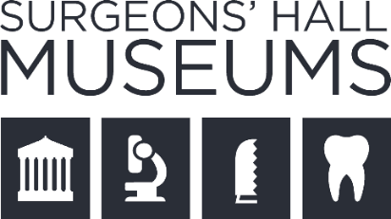
Collection Image Request
Research Use Only

To make our collections accessible, we do not charge for the supply of existing images for research use. We supply digital images for research in jpg format. Some of our older digital images may be of a lower quality. Additional requests for higher-resolution images or new digitisation may result in charges.
If permission is granted images will be provided using the Royal College of Surgeons of Edinburgh’s sharing network. Please note that no other sharing platforms such as WeTransfer are possible. We aim to respond to your photography request within 5 working days.
Terms and Conditions
- Individuals are reminded that images are to be used for study and research purposes only, and that any images provided must not be reproduced in any format other than that agreed. Further permissions must be sought for reproduction.

- Any supplied images must not be shared on any social media platform.

- We do our best to supply requested images - however this may not always be possible, due to copyright, sensitivity, or collection care restrictions.

- We owe a great deal to those whose bodies are used to further our knowledge of human anatomy and disease and as such we expect images of human remains to be treated with the same respect. Consequently, we reserve the right to deny image requests where necessary.

- We ask that research outcomes are shared with the museum to record collection use and potentially improve the information we hold about the collection.

- By signing the form below, you are confirming your agreement to abide by the above terms and conditions.

Print Name:
Signed:
Date:
Image Request From
Personal/Research Use Only
Individual Name
Name of Organisation
Are the images to be used for personal/academic research or teaching?
Please outline the need for the requested images and a description of intended use
Please provide details of your research or study, including the intended outcomes?
Description of requested images
(Please include object number where possible)
Additional information
Date Required
Preferred contact method:
Email address, telephone, address

This form should be returned by email to:
Surgeons’ Hall Museums, The Royal College of Surgeons of Edinburgh
museum@rcsed.ac.uk

